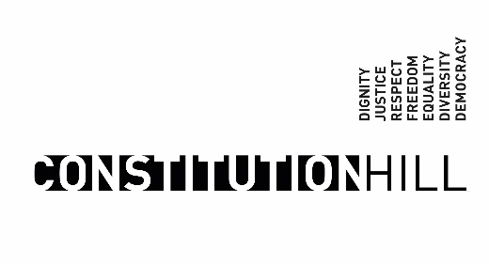
CALL FOR APPLICATIONS: CHIEF EXECUTIVE OFFICER OF THE CONSTITUTION HILL DEVELOPMENT COMPANY

(5 YEAR FIXED TERM CONTRACT WITH THREE MONTHS’ PROBATION, GRADE F1, SALARY TOTAL COST OF EMPLOYMENT)

The Constitution Hill Development Company SOC Ltd is a subsidiary of Gauteng Growth and Development Agency (GGDA), mandated and funded by the GGDA to assist to promote the site as a heritage, tourism and education precinct that expresses the values of South Africa’s Constitution and renders them physical for broad range of audiences. The Constitution Hill strives to create and sustain programmes that build and express the character of the precinct as, a global beacon for human rights, democracy, and reconciliation, driven by public participation, a vantage point that gives an understanding of our society in transition, a lekgotla where we meet to talk to each other and celebrate our diversity, a gateway from which to explore Johannesburg and its diverse tourism attractions.
The company is looking for a suitably qualified and experienced candidate to be appointed on a five-year fixed-term employment contract. Reporting to the Group CEO and the Board, the successful incumbent will provide strategic leadership to the Company’s growth in the sectors; develop a long-term vision, strategy, and strategic plan to advance the Company's mission and objectives and to promote revenue, profitability and growth as an organisation.
The candidate will be expected to oversee Company operations, both services and facilities management, to ensure production efficiency, quality, service and cost-effective management of resources with due consideration to risks. Other key performance related aspects of the job include:

- Foster a corporate culture that promotes ethical practices, integrity, and a constructive work climate, enabling the Company to attract, retain and motivate a diverse group of quality employees.
- Promote and develop the good name and values of the company in order for it to grow and maintain its benefit to the public and other stakeholders.
- Ensures the effective and efficient administration of the Company striving for best practice in good governance.
- Ensure compliance with the provisions of the PFMA Act, Treasury Regulations, and any relevant legislation.
- Development and execution of Constitution Hill Strategy in alignment with that of the Gauteng Growth and Development Agency, Gauteng Department of Economic Development, Provincial and National Government, to ensure the maximization of shareholder value and the long-term success of Constitution Hill.
- Oversee the development of business strategies based on a five-year plan, revenue model, and implementation framework that will ensure the full development of the Site and secure Constitution Hill as a Heritage, Education and Tourism entity that is financially viable.
- Provide leadership and oversight to ensure development of innovative business models for engaging public, the private sector and potential tourist industries.
- Strategic promotion and development of Constitution Hill initiatives that establish it as a key tourist and events facility in Gauteng.
- Oversee the implementation of all strategic functions of property management of the site and new developments.
- Define strategies for effective facilities management and maintenance of the entire site and ensure implementation thereof.
- Ensuring the strategic engagement and networking with stakeholders including major international, national, and local industries sectors to position the Site as a strategic partner.
- Keeping a successful interface between Constitution Hill, GGDA, Government and industry, and building strong links and strategic partnerships and ensuring effective feedback mechanisms.
As a minimum, applicants should have the following requirements:
- Post Graduate Qualification (NQF Level 8) in Management; or Business Administration; or Arts and other related fields is required.
- Masters; or MBA; or MBL will be an added advantage.
- 10 years’ experience in Executive Management position
- Extensive knowledge on Heritage Site Management and Tourism.
- Knowledge of infrastructure development, property management and facilities management.
- Sound knowledge of strategic and operational planning, including monitoring and evaluation; knowledge of the PFMA.
- Experience in dealing with government and government agencies, demonstrated ability to build strong and beneficial relationships with both government and the private sector.
- Advanced communication and interpersonal skills coupled with creativity to achieve customer excellence

Preference will be given to people with disabilities.

Applications should be submitted online: https://bit.ly/GGDAGroupRecruitment Enquiries should be addressed to: recruitment@conhill.org.za

Applications must be submitted and accompanied by curriculum vitae with contactable references, certified copies of qualifications and identity documents.

The closing date for all above position is the 27 February 2024, diversity is encouraged, preference will be given to Women, Youth and People with Disabilities and only shortlisted candidates will be contacted.

“The Protection of Personal Information Act (POPIA) came into effect on 1 July 2021. The GGDA respects your privacy and is committed to keeping your personal information secure and confidential. The Group will ensure that in Processing an Applicant’s or Employee’s Personal Information, it will adhere to its obligations in terms of POPIA. By virtue of you applying for this position, you give The Group the consent to keep and or process your information as pe POPIA”

Constitution Hill reserves the right to make an appointment.

