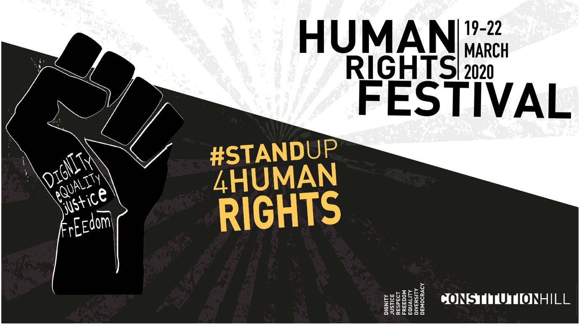
PRESS RELEASE
Constitution Hill Human Rights Festival 2020

JOHANNESBURG (December 10, 2019)

On December 10th 1996, the UN’s International Human Rights Day, South Africa’s President Nelson Mandela signed into law, South Africa’s world-renowned constitution. This act took place in Sharpeville to acknowledge the atrocities of the Sharpeville massacre.
Human Rights Day in South Africa is marked annually on March 21st – the day of the Sharpeville massacre. Constitution Hill’s Annual Human Rights Festival will take place between the 19 and the 22 of March 2020. This year marks the 60th anniversary of the Sharpeville massacre, presenting us with a poignant moment to acknowledge the immense sacrifices that have been made by countless South Africans in the struggle for human rights.
It is the human rights together with the values and the mechanisms of democracy entrenched in the South African Constitution that provide us with the tools to confront the challenges we still face today.
“WE THE PEOPLE …..So begins the preamble to our country’s constitution. March 2020 will see Constitution Hill host the third annual Human Rights Festival and together with the Constitution Hill Trust, the launch of the We The People campaign – aimed at defining this next decade as one of active commitment by “we the people” to constitutionalism.
It is the intention of this campaign, under the theme of ‘We, the People’ that the public takes ownership of the Constitution. While the last decade saw the violation of our Constitution on so many fronts, we have also witnessed its ability to guard our fundamental human rights. The next decade should be defined by a commitment to the Constitution,” says Dawn Robertson, CEO Constitution Hill.
The highlight of the Festival will be launch of Constitution.za, the digital platform for South Africa’s Constitution and the breaking of ground for MARCH (Museum and Archive of the Constitution at the Hill).

“Constitution Hill was always intended as a place where the archive of the Constitution would be preserved for generations to come. That dream is now being realized through the launch of Constitution.za - a website that will tell the story of how the Constitution was made and also host the archive of one the most celebrated Constitutions in the world. Until now, the archive has been inaccessible. The launch of constitution.za at the Human Rights Festival in March 2020 will be a proud moment in the efforts of recovering our history and ensuring that the story of constitution-making becomes accessible at home and in the world,” says Cheryl Carolus- chairperson of the Constitution Hill Trust

The Constitutional Court will form the backdrop for the four-day festival which will include an interactive activist row hosted by social justice organisations, pertinent panel discussions, film screenings, poetry readings, art exhibitions and theatre & dance performances.
The WE THE PEOPLE Music Concert will take place on Saturday 21 March and the annual Constitution Hill “We the people Walk” will take place on Sunday 22nd March. Participants are encouraged to walk for causes they support.
The entire festival is free and open to the public.
ENDS
- Visit www.humanrightsfestival.co.za to get a sense of last year’s vibe

- Organisations wanting to participate in HRF 2020 should apply here

- Journalists interested in covering the Human Rights Festival or who would like to interview festival organisers or participating Human Rights organisations should contact: Ms Janine Muthusamy: janine@conhill.org.za

About Constitution Hill:Constitution Hill is a living museum that tells the story of South Africa’s journey to democracy. The site is a former prison and military fort that bears testament to South Africa’s turbulent past and, today, is home to the country’s Constitutional Court, which endorses the rights of all citizens. There is perhaps no other site of incarceration in South Africa that imprisoned the sheer number of world-renowned men and women as those held within the walls of the Old Fort, the Women's Jail and Number Four.

Constitution Hill is also a place of contrasts: of injustice and justice, of oppression and liberation. Our precinct is testament to the importance of preserving sites of atrocity for posterity, and to recreating them so that they can serve the purposes of the present and serve to mould the future. We offer daily tours of the precinct and conduct regular public events, enabling visitors from every walk of life to interact with our space. There are also a variety of venues on our site available to suit your every eventing need, from small private functions to large corporate conferences.
For more information, visit www.constitutionhill.org.za

